Name:J.Pruthvi raj

Hallticket:2303A52181

Batch-42

Assginment:14.1 Task:01
Portfolio Website Design
You are building a personal portfolio website to showcase your work.
Requirements:
- Create sections for About Me, Projects, and Contact.
- Use AI to:
- Suggest color palettes and typography.
- Create a responsive layout with Grid/Flexbox.
- Add smooth scrolling navigation.
Prompt: I want to develop a frontend for the my portfolio
Code:
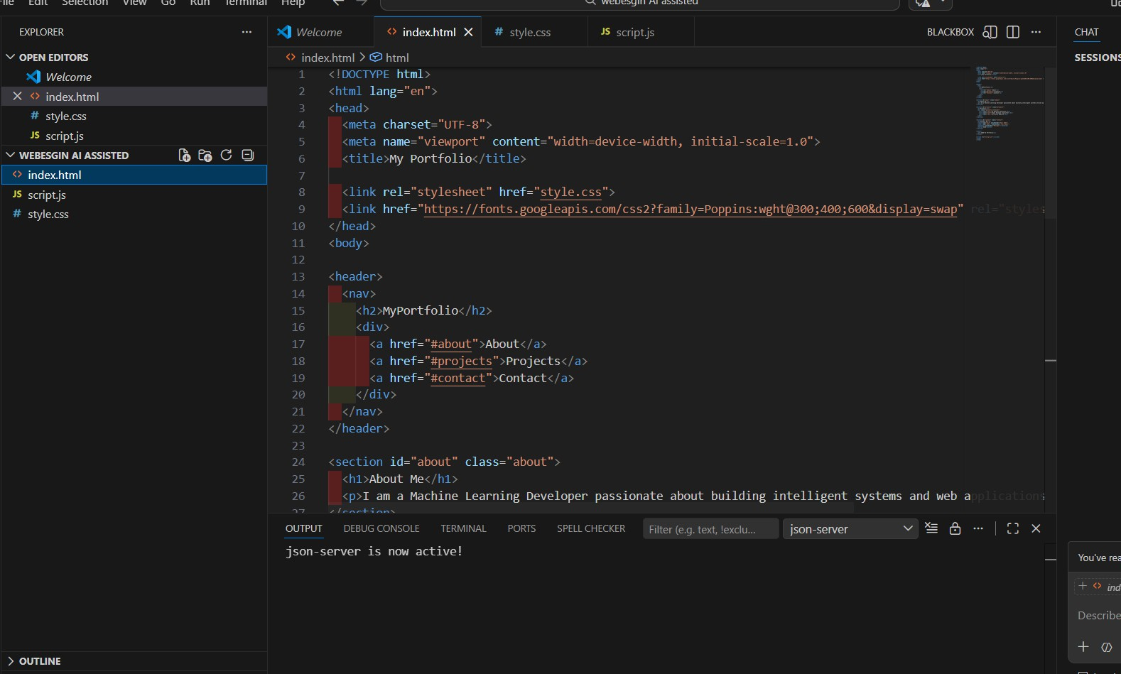

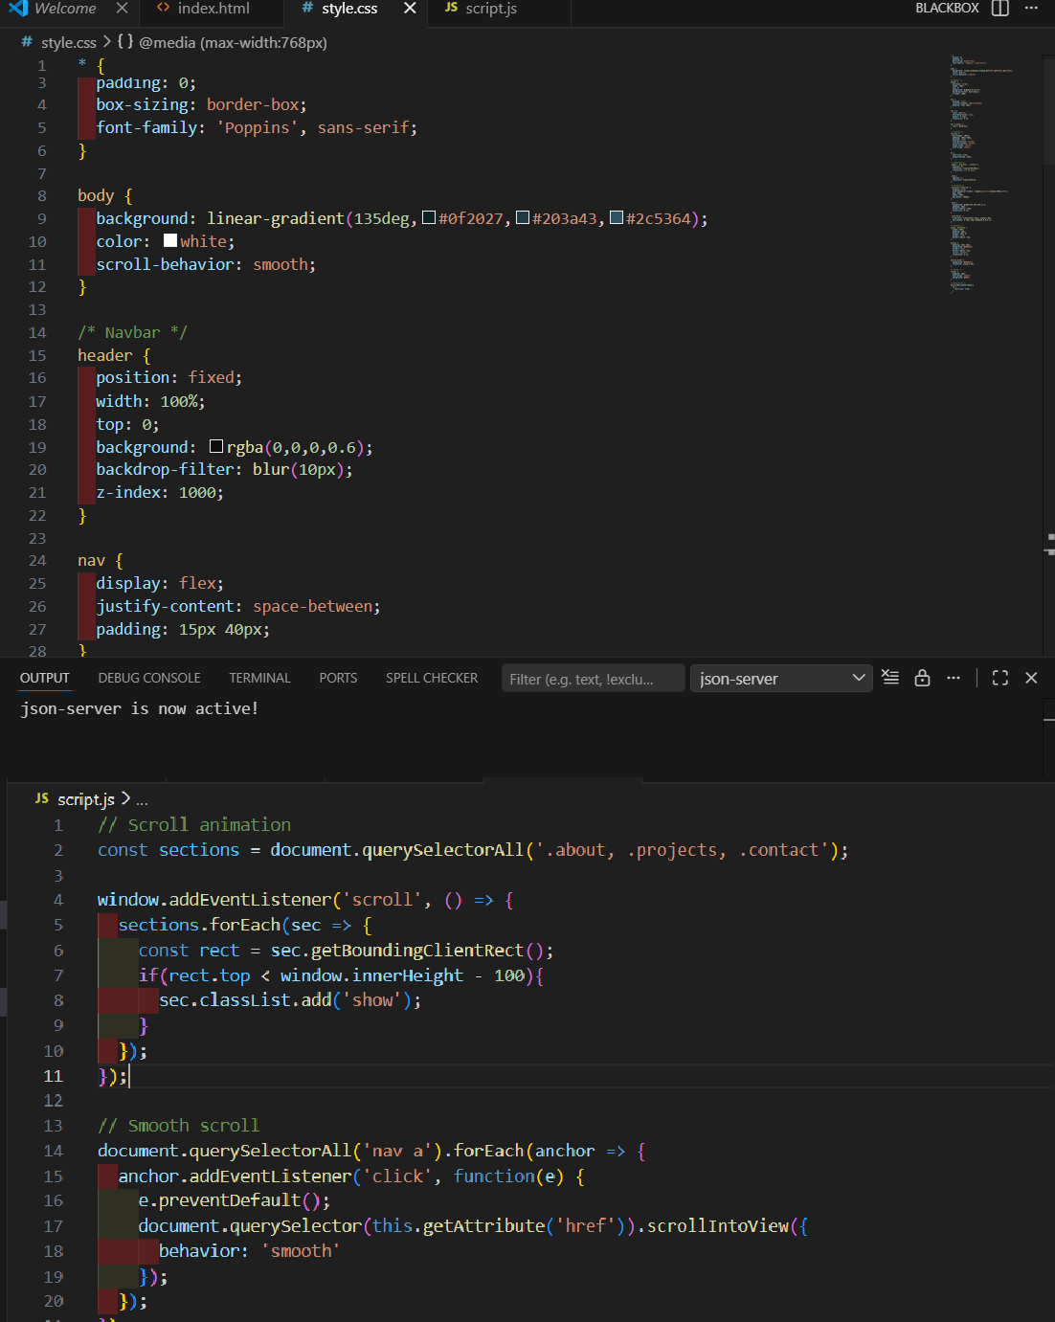
Output:

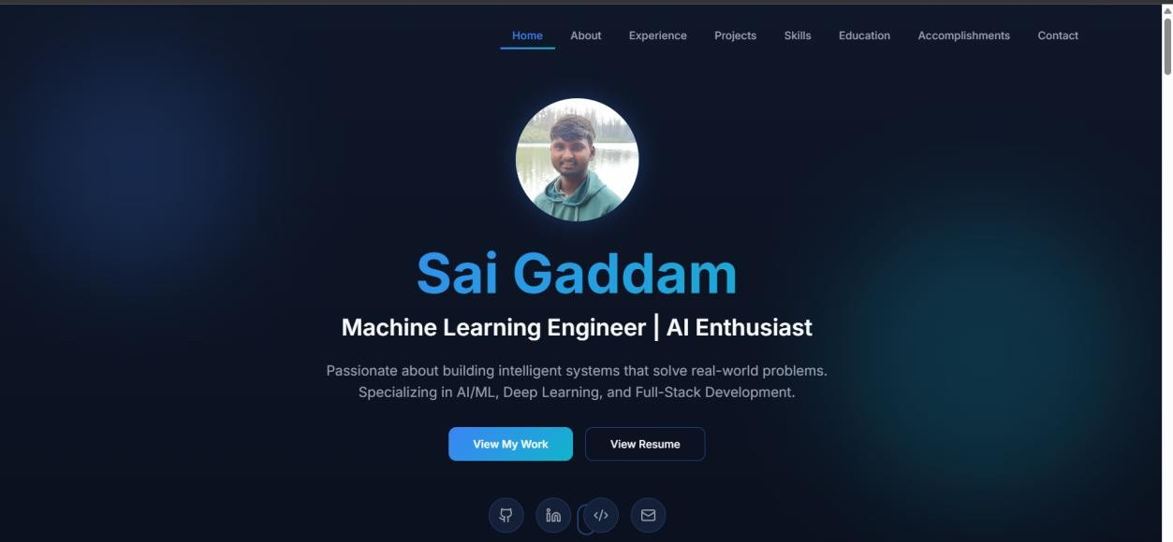
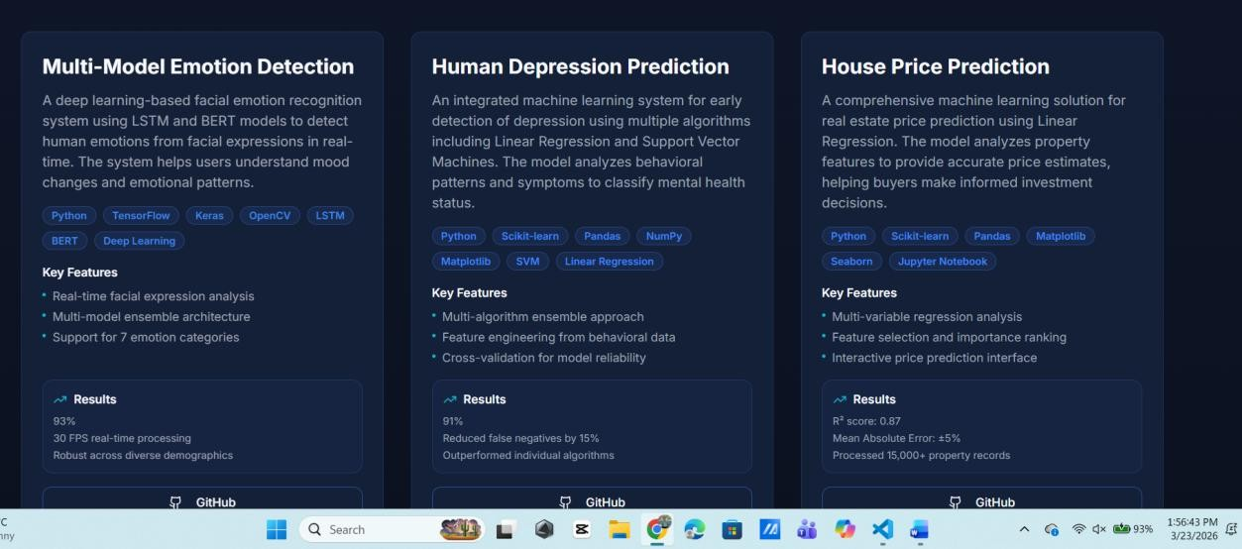
Observation:
The portfolio website was successfully developed using HTML, CSS, and JavaScript with the help of AI-assisted design techniques. The structure of the website includes three main sections: About Me, Projects, and Contact, ensuring a clean and organized layout
Task:02
Task 2 – Online Store Product Page
Design a product display page for an online store. Requirements:
- Display product image, title, price, and "Add to Cart" button.
- Use AI to:
- Style with BEM methodology.

- Make layout responsive.
- Add hover effects and "Add to Cart" alert.
Prompt:for this task create e-commerce website using html css js Code:
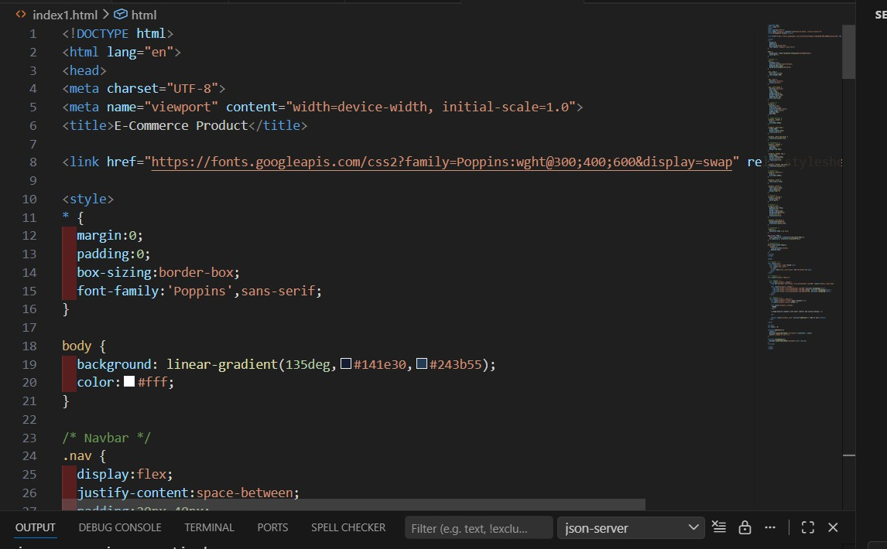

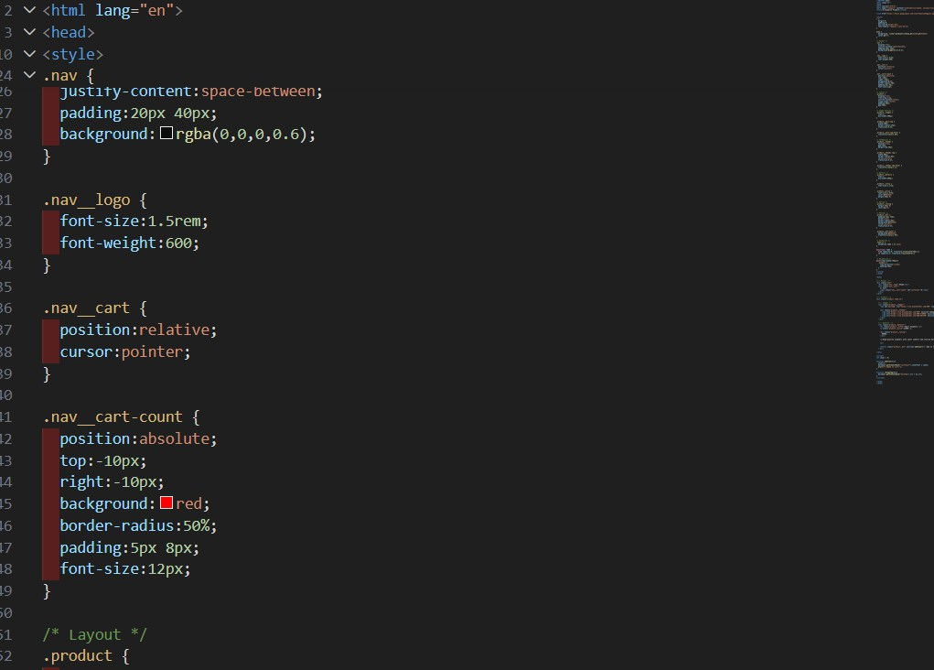

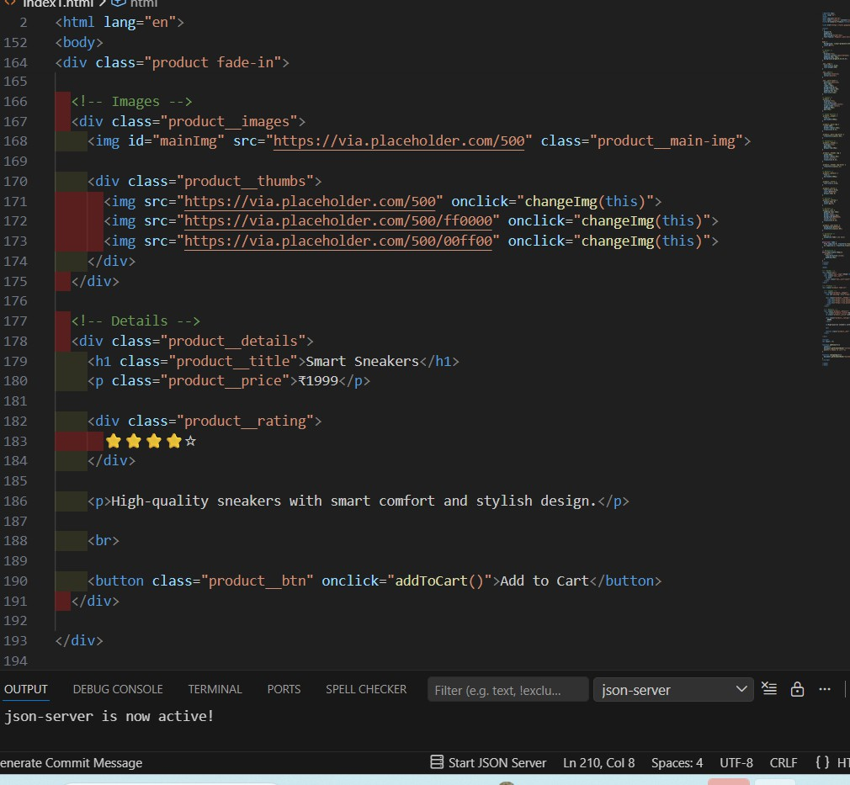

Output:

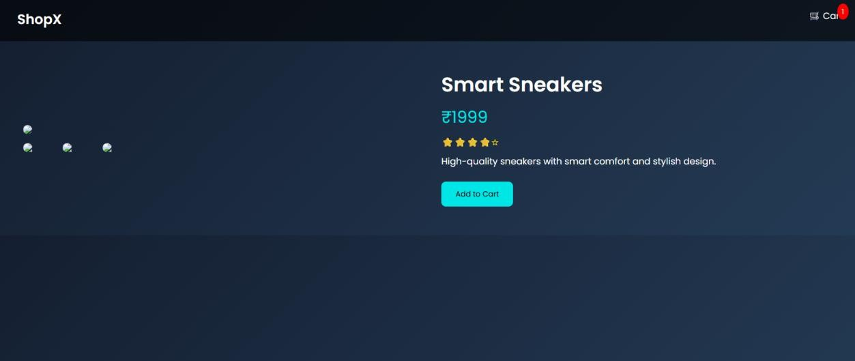
Observation:
The online store product page was successfully designed and developed using HTML, CSS, and JavaScript, following modern web design practices. The page displays essential product details such as product image, title, price, rating,
and an “Add to Cart” button, ensuring a complete e-commerce experience.
Task:03
ask 3 – Event Registration Form
Build an event registration form for a conference. Requirements:
- Collect name, email, phone number, and session selection.
- Use AI to:
- Add form validation with JavaScript.
- Make the form accessible with labels and ARIA.
- Style with a professional look.
Prompt:create event management system using HTML CSS JS Code:

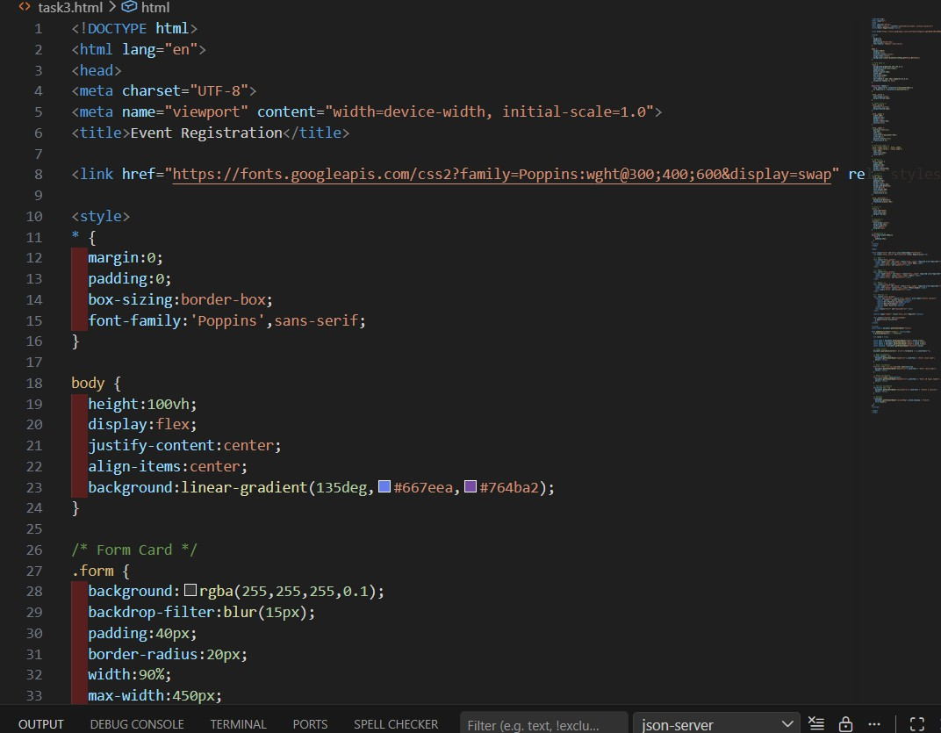
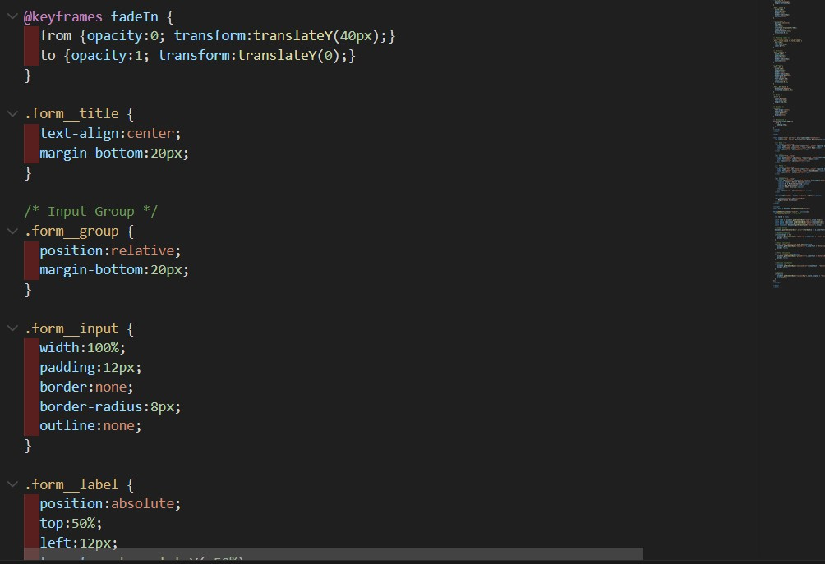

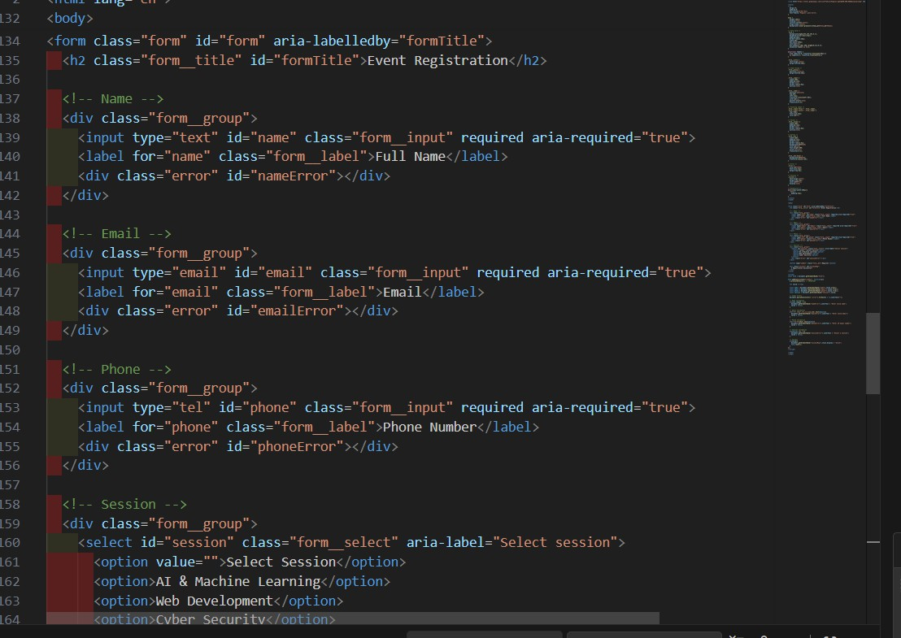
Output:
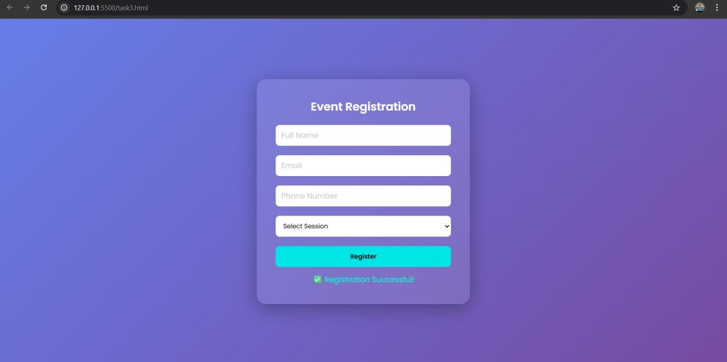
Observation:
The event registration form was successfully designed and developed using HTML, CSS, and JavaScript, incorporating modern UI design principles and accessibility standards. The form collects essential user information including

name, email, phone number, and session selection, ensuring a complete registration workflow.
Task:04
Task 4 – Resume Website
Build a one-page online resume. Requirements:
- Sections: Profile Summary, Skills, Education, Experience.
- Use AI to:
- Propose professional typography styles.
- Align sections using CSS Grid.
- Add smooth scroll navigation between sections. Prompt:
Create a website for the resume bulding Code:
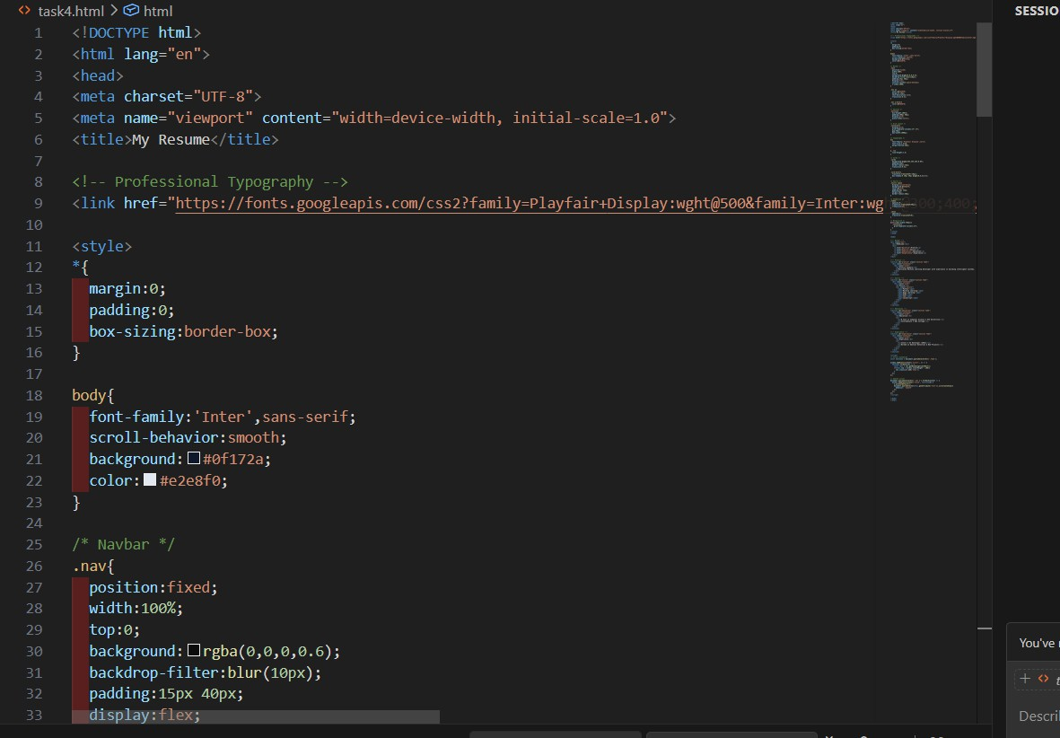

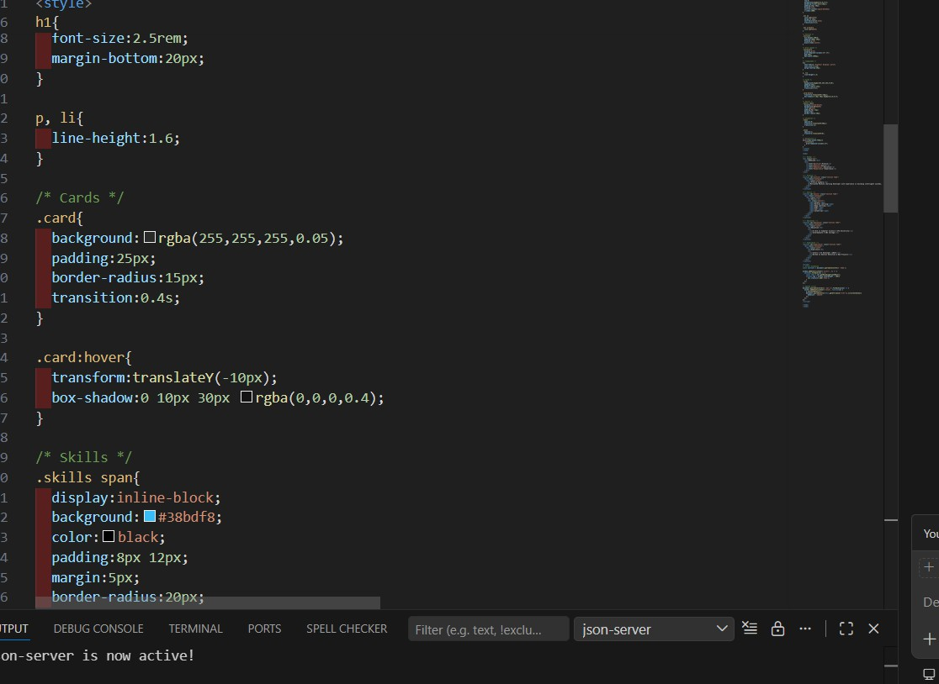

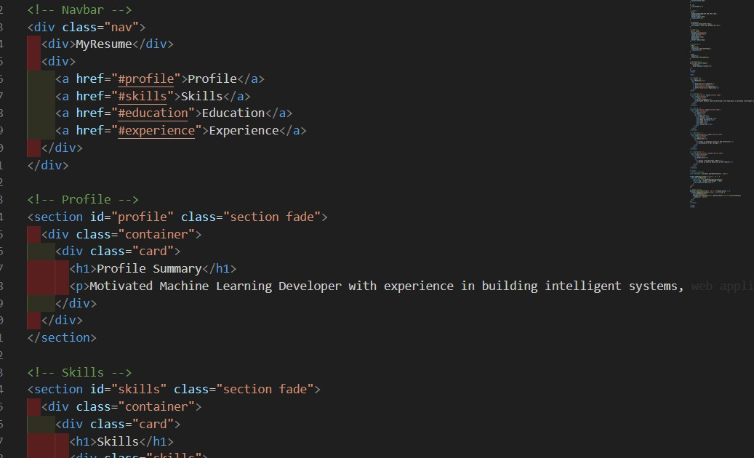
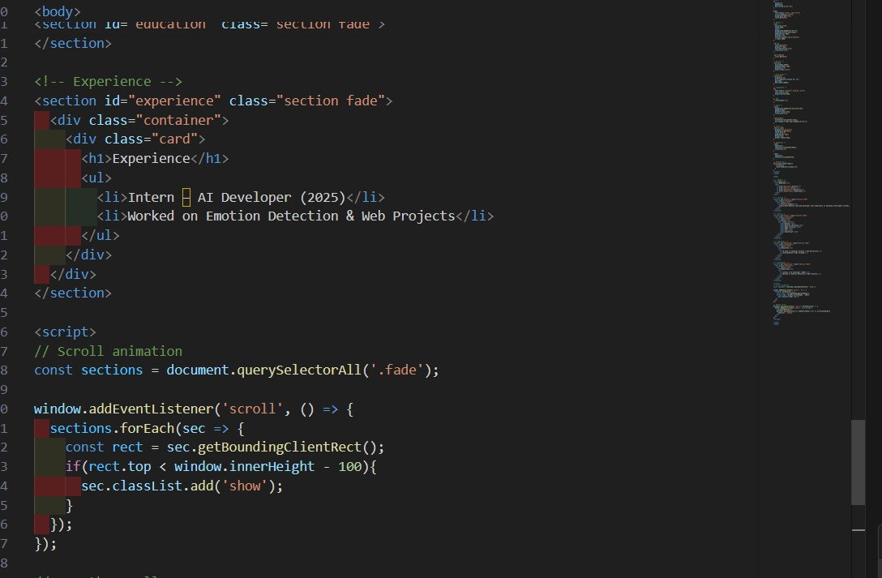
4
Output:

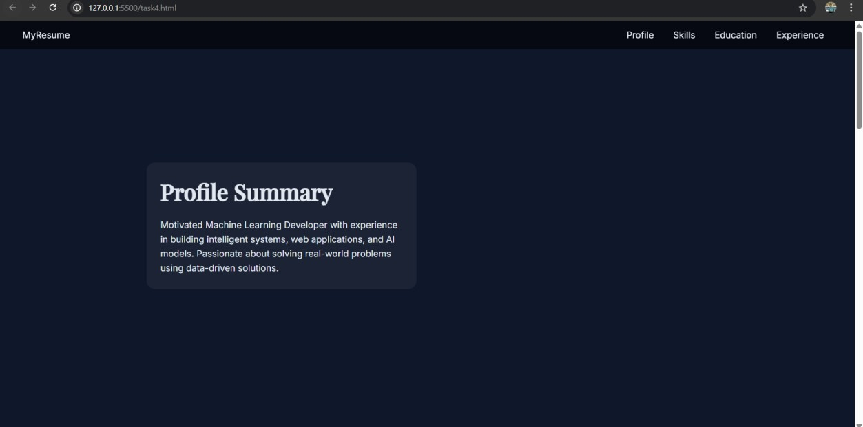

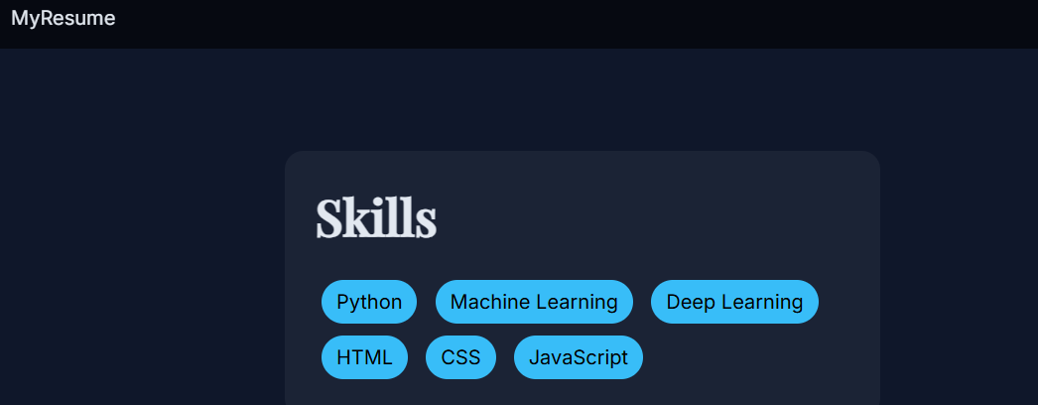
Observation: The one-page resume website was successfully designed and developed using HTML, CSS, and JavaScript, following modern web design and user interface principles. The website includes essential sections such as Profile Summary, Skills, Education, and Experience, providing a structured and comprehensive overview of personal and professional information.
Task:05
Task 5 – Restaurant Menu Page
Design a digital menu page for a restaurant. Requirements:
- Display menu items with name, description, and price.
- Use AI to:
- Suggest a food-friendly color palette.

- Design a responsive card-based layout.
- Add hover effects on menu items.
Prompt:create web application for my requirements with more relastic animation
Code:
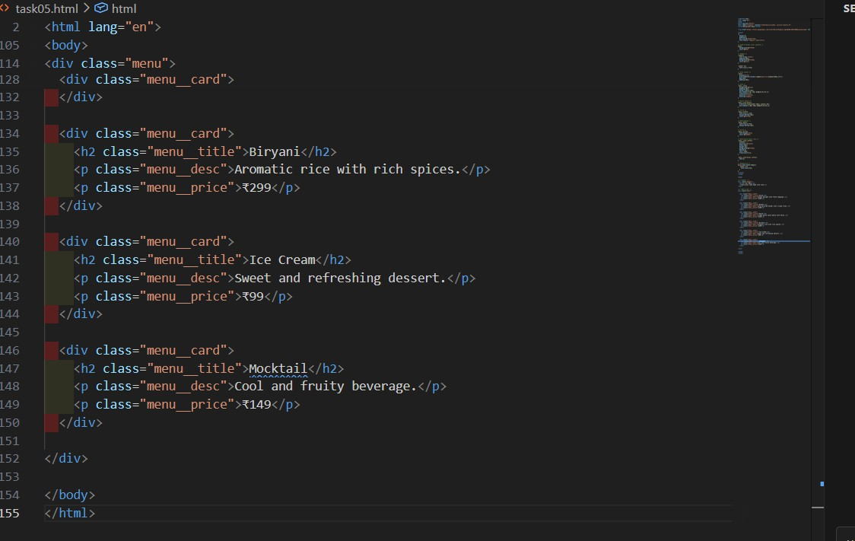

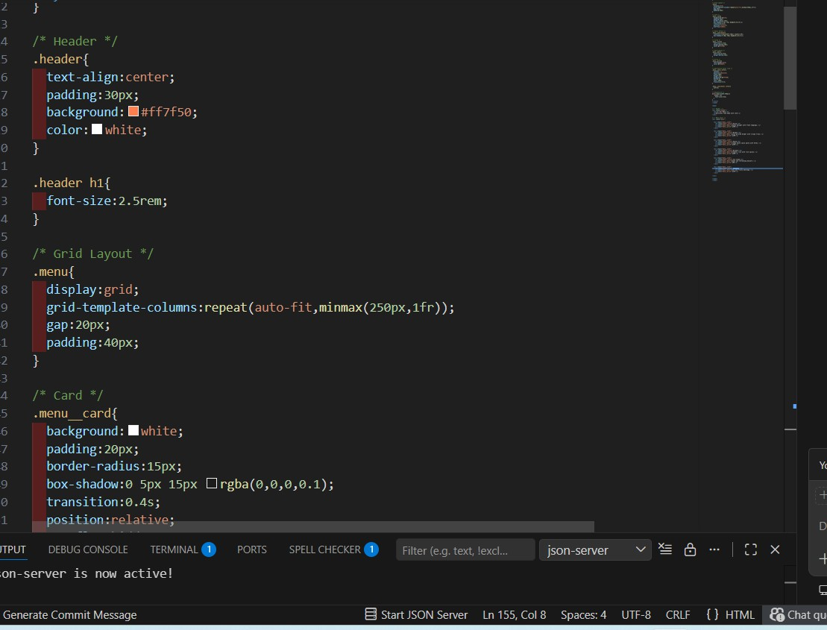

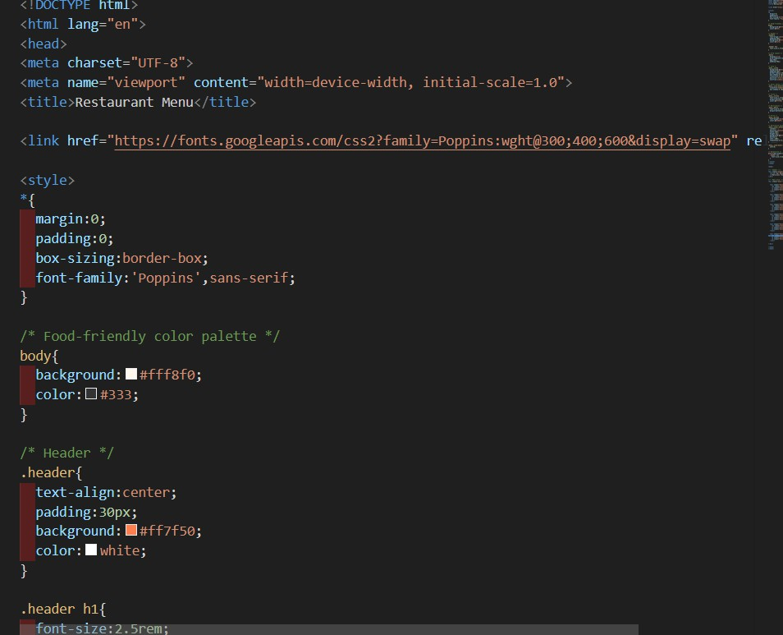
Output:
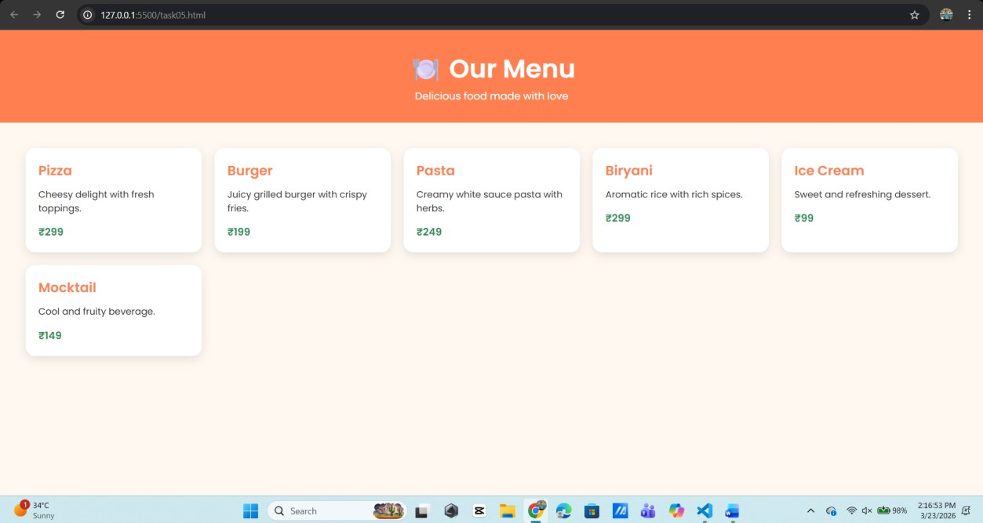
Observation :

he restaurant menu page was successfully designed and developed using HTML and CSS, following modern web design principles. The page displays various menu items with essential details such as item name, description, and price, providing a clear and user-friendly digital menu experience.

